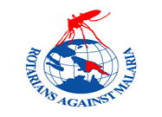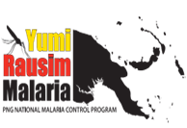

**NATIONAL MALARIA CONTROL PROGRAM**

**ROTARIANS AGAINST MALARIA**

**CHASING MALARIA QTR 3 REPORT 2020**

**KAIRUKU HIRI - CENTRAL PROVINCE**

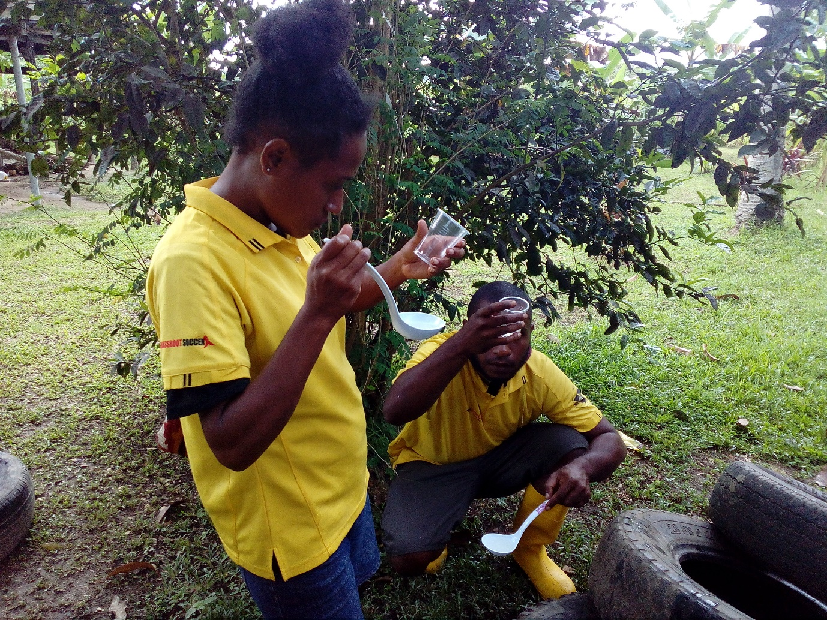

Coach Zico and Amelia from Skillz PNG collecting and identifying Mosquito laves at Kerea Primary School.

**Reporting Period from - 01st July to 30st September, 2020.**

**Third Quarter Report for Chasing Malaria Program in Central Province.**

Report Prepared by: Kila Tom

**RAM Chasing Malaria Project Supervisor**

1. **Executive Summary.**

The Chasing Malaria Program of the Rotarians Against Malaria (RAM) of the Rotary Club of Port Moresby in Papua New Guinea (PNG) is a malaria control program which works with health system, rural communities and with the general public to promote malaria prevention, particularly the use of Long-Lasting Insecticidal Nets and other sustainable ways of controlling mosquitoes and malaria. The Chasing Malaria program is currently located in Gulf, Central and NCD Provinces and is fully funded by both Rotarians Against Malaria (RAM) Australia RAM PNG and also Exxon Mobil.

The program has three components,

1. Giving Long Lasting Insecticidal Nets (LLINs) to all Rapid Diagnostic Test (RDT) positive malaria patients (Started 2014). These cases all the mapping where all the positive cases of malaria to highlights hot spots of malaria in these provinces. This is supported by an IT officer who is funded by RAM who enters all the data received from the field and maintains the data base. Mapping of all positive malaria cases is done by the RAM Programme Manager Tim Freeman.
2. Supplying good LLINs on a cost recovery basis (revolving fund) to the private sector and other organizations (First started in 1997).
3. Community Based Interventions – RAM Chasing Malaria Project has a Community Based Malaria Control Programme mainly based in schools but also in communities where communities request assistance. This program started in 2014 in Hula area of Central Province but was abandoned when it was found that there was little malaria in the area and the project manager resigned. The programme now works in eleven schools and surrounding communities in three areas, Waima (3 schools), Bereina (2 schools) and Kuriva (6 schools) (Started in 2012).

This report highlights the activities of the school’s program which is being supported by RAM Australia. This program involves malaria health information to all pupils of the school together with the formation of school clubs which go out weekly from the schools to look for and eliminate mosquito breeding sites.

School Teachers in the Vanapa Brown Clusters have also been taught on how to perform test and treat malaria so treatment of malaria in these schools is part of this project.

Activities in the Kuriva area are going well. Twelve teachers were trained in the testing and treatment of malaria in 2019, and these teachers continue to test and treat sick school children as well as people in the surrounding community. Referring to Table 6.2, the project is now regularly working with six schools in Kuriva. Every school has a malaria club which in most weeks are carrying out mosquito control activities. The project officer responsible for this program is regularly visiting and supporting the school activities during this period.

It should also be noted, that the project wished to expand its activities into four more primary schools between Kuriva and Bereina but the Covid Outbreak has stopped this from happening as more Covid cases have being reported towards the end of last and beginning of this third quarter.

However, in addition to his regular activities, the Chasing Malaria Officer has also assisted in the following Global Fund activities when there was a need for his skills. Activities include:

* Setting up Home Based Management of malaria (HMM) program elsewhere in Central Province and
* Assisting in drug distribution with the Regional Malaria Coordinators in Central Province mainly in Kairuku Hiri district.

For further details, see below and please find a full history of the Chasing Malaria Program in Annex

1. **Methodology.**

Chasing Malaria project has been trialling strategies and approaches that will be required to drive down malaria to elimination in areas of low disease incidence. The program is funded by RAM and works in the National Capital District (NCD) where malaria rates are already low while Central Province has been an intense increase in malaria incidence in some parts of the province, particularly in areas like Kairuku-Hiri district.

* 1. The first component is Surveillance. RAM has designed and printed standard record books for all of the health clinics which record details of all malaria diagnostic tests including the home address and recent travel for all positive cases. These sheets also feed information into the monthly reports to the National Health Information database. The positive cases are mapped across the regions and malaria clusters are identified for follow-up.
  2. Where malaria case clusters are identified, Ram officer and his team trainee local community volunteers work with the local schools to teach the students about malaria and mosquito life cycles and to search out all the mosquito breeding sites around the cluster location.
  3. Breeding sites are mapped by using different colour code pins/GPS and regularly checks are done on the breeding sites. When they are active (i.e. contain mosquito larvae) specific strategies are developed to destroy the larvae. These include draining or filling, introducing fish to eat the larvae or spraying larvacide. However, method of Larvacide spraying is not being strategies in the schools.

* 1. RAM is proposing to continue and consolidate the activities as outlined above. We are particularly trying to get school clubs to carry out the larval source reduction consistently on a weekly basis using a variety of tools including larviciding The pilot project is a work in progress with new and refined approaches being developed and assessed but it is already having an impact on malaria rates the local people are very supportive, understand the aspects of malaria transmission and value their bed nets.

1. **Program Achievements in Third Quarter.**

Chasing malaria started off in a very sluggish phase due to multiple reasons however, Covid 19 and the absenteeism of students are the two main excuses used by the school health teachers which however, slows down the whole process of implementing school malaria club activities in the second and third quarter phase in 2020.

Despite the slow start chasing malaria programme has managed to covered and set up malaria clubs in six (6) selected schools under Vanapa Brown cluster, and the good news is that schools have resume normal classes on the 27th July, 2020.

Listed below are programmatic results achievement as follows;

* 1. Berere primary school has being elevated from elementary to function as primary school after it was recognised by the Central Provincial education division. These made the total number of primary schools under Vanapa brown cluster to seven schools in total. However, without delay, formation of school malaria clubs had been established and school club being sent out each week to look for malaria breeding sites and destroying them where necessary. Refer to Table One
  2. All seven schools have established malaria clubs in the respective schools however; out of the seven schools only five schools who are still active and currently Identifying mosquito breeding sites in their schools. However, the other two schools which are Edevu and Sabusa primary schools have being given instructions by their School Board of Management from performing any group activities or sports in their schools due to Covid 19 pandemic. However, refer to table one, the two schools which are mentioned above have only taken part once in conducting malaria activity in their schools for quarter 3. Therefore, it can be seen as out of the seven schools, only five schools who are actively performing malaria and other general duties in the respective schools.
  3. However, end of each month, RAM officer visits all seven school health teachers or CMVs to collect malaria reports and also conduct onsite refresher training on 3Ts or Test, Treat and Track how to perform RDTs
  4. Listed below are some of the activities which are carried out by the malaria clubs while mapping out the breeding sites. Once the mosquito breading site is identified it is however, map using different colour pins to indicate mosquito parasite and mosquito hot sport areas and regular checks are done on the breeding sites. When they are active (i.e. contain mosquito larvae) specific strategies are developed to destroy the larvae which are highlighted below are as follows;
* Collecting of mosquito larvae,
* Destroying breeding sites around teacher’s houses,
* Filling in tyre tracks and other puddles of water with mosquito larvae, and
* Visited few nearby villages to ensued that there are no breading sites for mosquitos to reproduce.
  1. Supervision visits to school health teachers who have being trained on Test, Treat, Track in all selected schools are ongoing to ensure proper recording and reporting is done at end of each month. Many surrounding communities around Kerea, Vanapa, Brown River primary and Kuriva have required malaria testing and treatments from the schools using the health teachers.
  2. School malaria prevalence survey is an ongoing requirement under the guidelines of the National Malaria Control Program (NMCP). First school survey was conducted in July, 2020 under the funding support from Chasing malaria program assisted school malaria prevalence survey in four selected schools under Vanapa Brown cluster, supervised by provided central provincial health authority (CPHA)
  3. Supervision visits to community malaria volunteers (CMVs) are also continuing to assist them in conducting refresher training on how to test, treat and track malaria cases.

1. **Constraints and Other Challenges.**

Health Teachers in all schools under Vanapa Brown cluster in Hiri district of Central province should note that they can play an important role in keeping their pupils healthy and active in all school activities. Malaria is a leading cause of absenteeism in central province mainly in Kairuku-Hiri district, which in the long run affects the performance of the pupils and the school as a whole. During this quarter one visits there were many issues identified. Some of these issues are frequently seen in most government and Church run schools and health facilities in Central Province and other parts of the country include the following;

* 1. Second Covid 19 lockdown in mid July 2020.
  2. Authority suspending classes in Central Province and NCD
  3. Poor attendance of students to classes,
  4. Teachers attending one (1) week refresher training organised by the Department of Education,
  5. Assisting Regional Malaria Coordinators distributing Anti-Malarial drugs and conducting M&E health facility visits in Manaus Province and also assisting the Global Fund program on Home Base Management of Malaria in Central Province etc. including areas around Kuriva.
  6. Generally, in the second and third semesters school malaria club activities have been going on well with few selected schools under Vanapa brown cluster. However, due to increasing numbers of coronavirus cases in the National Capital District (NCD) around mid-June and July 2020, all schools in the Central province were ordered by Central Education Authority to suspend classes for two 2weeks due to high intensive Covid 19 cases reported in NCD.
  7. Schools in NCD and Central province were forced to lockdown classes for the second time on July, this year 2020. However, classes were suspended due to Ccovid 19 pandemic lockdown. This was even made worse when students in central province particularly schools in Vanapa Brown cluster in Hiri district decided to stay away for another extra week, which brings the total of three (3).
  8. From time to time school malaria club members are being disturbed with the new education strategy schedule being introduce due to covid 19 pandemic situation. Classes or grades have been Sheduled for morning and afternoon classes due to governments New Normal policy.

1. **Conclusion.**

The Chasing Malaria Programme is considered very important as a model for other partners to copy in other places in Central province including other provinces. Without community engagement and surveillance, there is little possibility of elimination of malaria in PNG. This is also a flagship of RAMs direct involvement in malaria control in PNG other than being a service provider to the National Department of Health through Global Fund contributions. This project gives Rotarians Against Malaria a powerful advocacy tool of being a leader in the control of malaria in PNG.

I would like to take these opportunities to thank the following people and organisations in assisting Chasing Malaria Program in Central Province since 2018 facilitating its activities under the National Malaria Control Program. Thank you for the partnership and integration of programs. The Chasing Malaria Program in Central Province is considered very significant as a model for other partners to copy in other parts of the country. Without community commitment and observation, there is little possibility of elimination of malaria in PNG.

This is one of top direct involvement in the National malaria control in PNG other than being a service provider to the National Department of Health through Global Fund contributions. This project gives Rotarians Against Malaria a powerful advocacy tool of being a leader in the control of malaria in PNG.

**Organizations:**

1. Rotary Club of Port Moresby
2. National Department of Health (NDoH)
3. World Health Organisation (WHO)
4. Central Public Health Laboratory (CPHL)
5. Exxon Mobil Oil
6. Institute of Medical Research (IMR) – Entomology Unite in Madang.
7. Central Provincial Health Authority (CPHA)
8. RMC Department of Rotarians Against Malaria – Global Fund
9. HMM Department of Rotarians Against Malaria – Global Fund
10. LLIN Department of Rotarians Against Malaria – Global Fund
11. Skillz PNG through YWCA
12. IRS Global Fund Program team members.
13. **Annexes.**
    1. Chasing malaria has continued to establish school malaria clubs in the schools under Vanapa Brown cluster. This year HMM program as assisted to train twelve 12 more HMM teachers to combat malaria in schools in the sub-divided district of Kairuku Hiri constituencies. Chasing malaria program has mainly focus its emphases in eliminating malaria endemic mainly in Kairuku Hiri district catchment with higher proposes of malaria cases being reported over the last five years and again in this year 2020 as presented above.
    2. Updates on school malaria clubs.
    3. History of the Chasing Malaria Program

ANNEX 6.1 - Updates on school malaria clubs.



ANNEX 6.2 - Updates Malaria In Central Province

***Data from 2020 NHIS Project Showing Relative Malaria Incidence Recorded by districts in Central Province***

According to graph shown above, it clearly illustrates that there is more malaria incidence in Kairuku Hiri district as compared with the other three districts of Abau, Goilala and Rigo districts. However, malaria incidence in all three districts of central province are less than ten percent (10%) which, is proven that there is little malaria in all three districts of Central Province. For this reason, it has been proposed to select and train local people to treat certain diseases such as malaria so people do not have to travel a long distance to seek treatment. Local people trained to treat malaria and other diseases are known as Community Malaria Volunteers or (CMVs).

**ANNEX 6.3**

**PROJECT PHOTOS.**

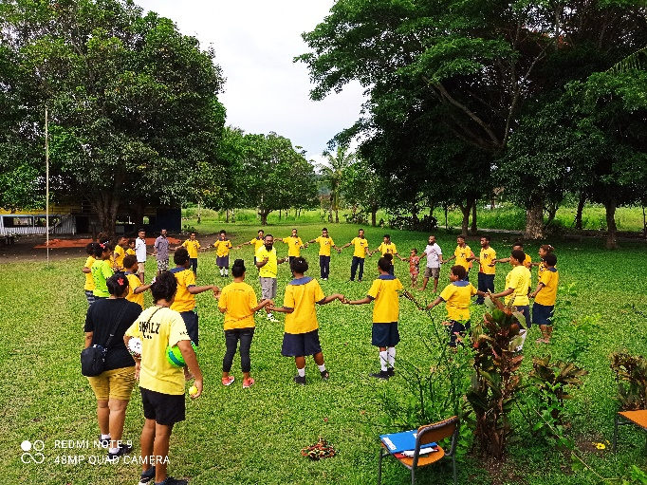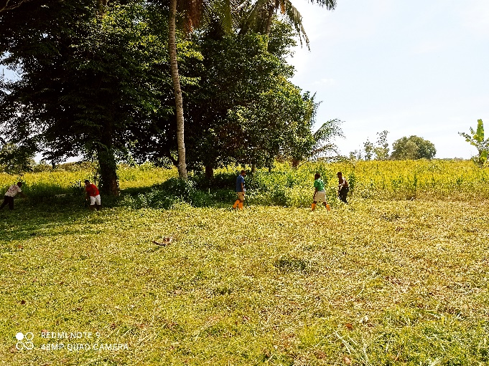 **Skillz coach conducting Skillz Training Malaria Club cutting tall buases**

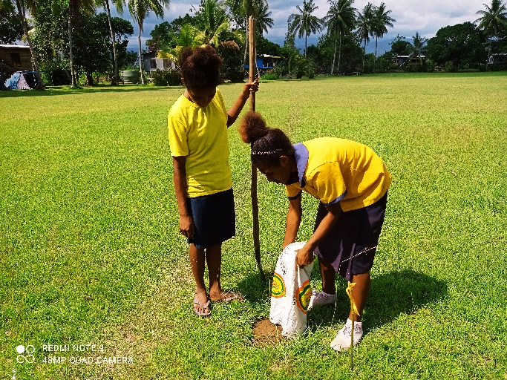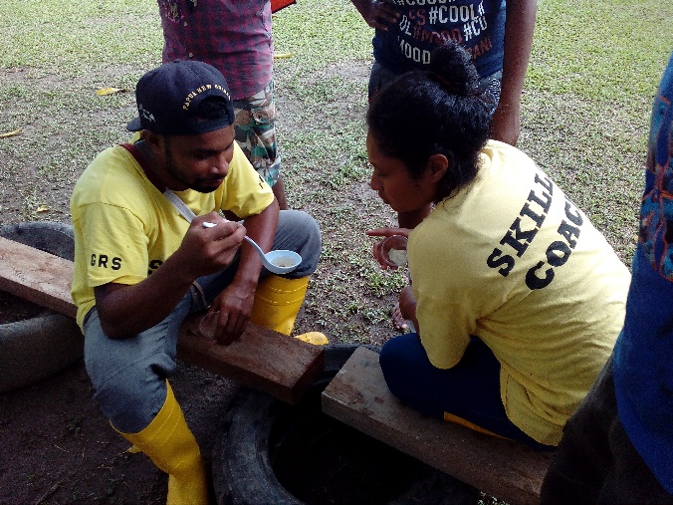 **Malaria Club filling out pot holes Skillz Coaches collecting mosquito larvae**

**ANNEX 6.4**

**History Of Rotarians Against Malaria And The Chasing Malaria Program**

Rotarians Against Malaria (RAM) is a nationally based organisation which was formed in 1997 by the Port Moresby Rotary Club in recognition of the tremendous burden that malaria imposes on the people of PNG.

From 1997, following a donations of nets from the Australian Government and the National Department of Health, RAM was selling about 40,000 nets a year through a very successful revolving fund: most revolving funds for nets used to run out of money by selling nets at too low a price, while the RAM project sold nets at a slight profit and managed to maintain the project for many years up until 2020.

In the early years, the nets sold were ITNs (Insecticide Treated Nets) which required retreatment of insecticide and RAM was involved in many instances in having retreatment campaigns. Retreatment however started to disappear in about 2003 with the introduction of LLINs (Long Lasting Insecticidal Nets) which did not require retreatment after each wash.

In 2004, the sale of nets slowed down due to a massive grant from the then new Global Fund. The role of RAM however, expanded during this period. With its experience with mosquito nets, RAM played an important role from 2004 to 2009 in assisting the government with the transport of nets from factories in Vietnam to delivering net to provincial locations from where the nets would be distributed by the National Department of Health.

At the end of 2009, due to a number of issues, Rotarians Against Malaria was asked by the Global Fund to take over the whole distribution of nets from the factory right down to village level. This program of household distributed has continued in partnership with the Department of Health for 10 years with the distribution of 12.2 million nets to household in PNG and a further 1.4 million nets distributed to pregnant women, boarding schools and prisons.

Apart from the Global Funds, RAM PNG also has come of its own funds as well as funds coming from RAM Australia. These funds have been used to start alternative projects particularly community-based activities.

The community-based program started in 2012 in Rigo Coastal area on the Hula road of Central Province. This project was abandoned after about a year when it was found that there was little malaria in the area resulting in little community enthusiasm and the project manager resigned.

The Rigo Project highlighted the need to identify places with higher malaria incidence. This lead to a new project where RAM funded nets to be delivered to all health facilities in Port Moresby and Central Province which would be given to RDT (Rapid Diagnostic Test) malaria positive patients of malaria. When issued a net, patients were asked a number of questions regarding where they lived, their use of nets and their travel history. This allowed RAM to build up a data base from which malaria could be mapped. In 2015, this project expanded into Kerema District of Gulf Province also. It was at this time that the program started to be called the Chasing Malaria Program.

This exercise identified that there was a lot of malaria in the Waima area of Kairuku Hiri District of Central Province and in 2016, the school program malaria project was initiated in Waima and Bereina and covered five schools in Waima and two schools in Beriena. This program involved working with schools to teach them all about malaria and start school clubs which would go out and destroy malaria breeding sites. The program also worked with the Institute of Medical Research (IMR) who came and carried out entomological studies in the area.

In 2018 a school prevalence survey was carried out in the Kuriva area of Kairuku District during the World Malaria Day celebration. The school surveys highlighted a huge malaria problem just outside of Port Moresby, and based on this, from 2018, the focus of the school program moved from Waima where malaria had dropped considerably to Kuriva where in the last two years, the program has worked with six schools and is now expanding into other areas of Kairuku Province.

It is sad to report that the activities started in Waima and Bereina all stopped. Throughout the program in 2016 and 2017, it was found very difficult to have communities or schools carry out programs with RAM staff present. When RAM staff moved to Kuriva, all activities in Bereina and Waima stopped but it is hoped that in 2021 these projects will be re-activated.

The sales of mosquito nets continues. However, this has been going at a very slow pace except in 2015 when the program employed a salesman who very successfully sold enough nets and other products to pay for his own salary. RAM has a target of selling LLINs in every district of PNG but is still looking for a manager for this project to ensure there is always stock and manage the day to day workings of this program.

Lastly, RAM together with its Chasing Malaria Program has an organizational mandate to work in malaria control and the distribution of LLINs in Papua New Guinea and has been working for many years with the National Department of Health (NDOH) and other partners including multilateral and bilateral agencies such as UNICEF and WHO (World Health Organisation), NGOs and church groups. In additional to mosquito nets and the Chasing Malaria Program, since RAM now worked in all areas of malaria control from Drug Procurement and Distribution, health facility supervision and training of village volunteers to test and treat malaria in what is known as the Home Management of Malaria (HMM) program. In terms of the latter program, the Chasing Malaria Program worked closely with the HMM program to also train teachers to test and treat malaria in the schools in which the program works.

Overall, the specific aim of the Chasing Malaria Program is to promote new practices of malaria control and empower communities to fight malaria within their own communities in programs which the Global Funds is not supporting.